**Software Requirements Specification**

For

**HEALTH CARE CHATBOT**

15-11-2021

Prepared by

|  |  |
| --- | --- |
| **NAME** | **ROLL NO** |
| Puneet Ibarit Singh | 102017091 |
| Sankalp SHARMA | 102197012 |

CSE

Computer Science and Engineering

Thapar institute of engineering and technology. Patiala

# Table of Contents

|  |  |  |
| --- | --- | --- |
| **Topic** | | **Page No** |
| Table of Content | |  |
| Revision History | | 3 |
| 1 | Introduction | 4 |
|  | 1.1 Purpose of the Project | 4 |
|  | 1.2 Target Beneficiary | 4 |
|  | 1.3 Project Scope | 5 |
|  | 1.4 References | 5 |
| 2 | Project Description | 6 |
|  | 2.1 Reference Algorithm | 6 |
|  | 2.3 SWOT Analysis | 6 |

|  |  |  |
| --- | --- | --- |
|  | 2.4 Project Features | 7 |
|  | 2.5 User Classes and Characteristics | 12 |
|  | 2.6 Design and Implementation Constraints | 12 |
|  | 2.7 Design diagrams | 13 |
|  | 2.8 Assumption and Dependencies | 19 |
| 3 | System Requirements | 19 |
|  | 3.1 User Interface | 19 |
|  | 3.2 Software Interface | 19 |
|  | 3.3 Database Interface | 20 |
|  | 3.4 Protocols | 20 |
| 4 | Non-functional Requirements | 20 |
|  | 4.1 Performance requirements | 20 |
|  | 4.2 Security requirements | 21 |
|  | 4.3 Software Quality Attributes | 21 |
| 5 | Other Requirements | - |
| Appendix A: Glossary | | 22 |

**Revision History**

|  |  |  |  |
| --- | --- | --- | --- |
| **Date** | **Change** | **Reason for Changes** | **Mentor Signature** |
|  |  |  |  |
|  |  |  |  |

**1.0. Introduction**

## 1.1. Purpose of the project

To lead a good and healthy life healthcare is extremely important. Normally Users are not aware about all the treatment or symptoms regarding the particular disease. For small problems users have to go personally to the hospital for check-ups which is more time consuming. Also handling the telephonic calls for the complaints is quite hectic.Sometimes it is very difficult to get the consultation with the doctor in case of any health issues.

The purpose of this project is to make a medical chatbot using AI which will diagnose the disease and supply basic details about the disease before consulting a doctor. to scale back the healthcare costs and improve accessibility to medical knowledge the medical chatbot is made. Few chatbots act as reference books, which helps the patient find out about the illness and assists with improving their wellbeing. The user is able to do the important advantage of a chatbot only: it can diagnose all diseases and supply necessary information. A text-to-text diagnosis bot connects patients about their medical issues and gives a customized diagnosis to support their symptoms. Hence, people will have a thought about their health and have the proper protection.

## 1.2. Target Beneficiary

This project is a health-care chatbot.The target beneficiary would be people of all age groups.This would be of great help for the senior citizens.During this pandemic it sometimes become difficult to get face to face medical assistance, through this chatbot the patient can get the desired medication and precaution to be taken on the basis of symptoms added by them.

## 1.3. Project Scope

Chat bots are an intelligent system being developed using artificial intelligence (AI) and natural language processing (NLP) algorithms. The medical chat-bots functioning depends on Natural language processing that helps users to submit their problem about the health. The User can ask any personal query related to health care through the chat-Bot without physically available to the hospital. In this project we will be using NLP and classification algorithms such as decision tree and random forest classifier.

A clinical chatbot which gives customized analyse dependent on side effects.This system helps users to submit their complaints and queries regarding the health. Customer satisfactions the major concern for developing this system. . The actual welfare of this chatbot is the facilitate the people by giving proper guidance regarding the good and healthy living.

This idea focuses on creating a chatbot which is free of cost and available throughout the day. The facts that the chatbot is free and can be accessed wherever the user is, be it their working environment, prompt the user to have it and use it. It saves the overhead involved in consulting specialized doctors.

## 1.4. References

Implementation of a Chatbot System using AI and NLP Tarun Lalwani, Shashank Bhalotia, Ashish Pal,

Shreya Bisen, Vasundhara Rathod https://www.ijircst.org/DOC/2_irp620.pdf

Self-Diagnosing HealthCare Chatbot using Machine Learning by Anil Kumar, Vamsi Krishna, Nikhila

Reddy,Rohith Kumar Reddy,Jeena Jacob (Department of Computer Science and Engineering, GITAM

School of Technology, GITAM University-Bengaluru Campus, Karnataka, India.5Associate Professor,

Department of Computer Science and Engineering, GITAM School of Technology, GITAM University-

Bengaluru Campus, Karnataka, India) http://sersc.org/journals/index.php/IJAST/article/view/19027/9666

### 2.0. Project Description

**2.1. Reference Algorithm**

The reference algorithm which we will be using for this project is the decision tree algorithm.Decision Tree is a Supervised learning technique that can be used for both classification and Regression problems, but mostly it is preferred for solving Classification problems. It is a tree-structured classifier, where internal nodes represent the features of a dataset, branches represent the decision rules and each leaf node represents the outcome.

Along with that several modules are used such as tkinter, os, webbrowser, numpy, pandas, matplotlib.

**2.3. SWOT Analysis**

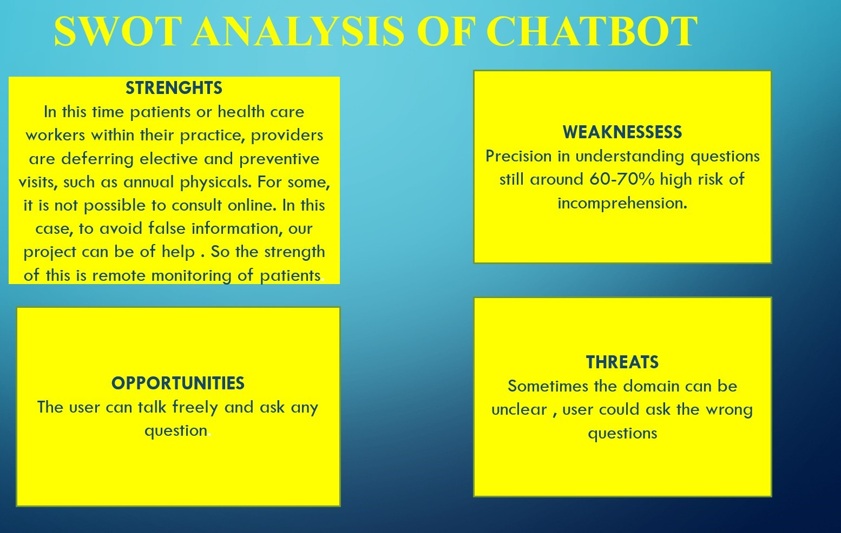

**2.4. Product Features**

### 1. Ever engaging patient support

A healthcare success is directly proportional to its availability for its patients. Even if you have enough staffing to attend to your patients through calls or in person it will fall short of patient satisfaction. But Chatbots prevent you from delivering anything less than prompt and desired reply for your patients.

Chatbots and make your work easy, produce more results as they are automated. You can convey your messages in the tone that you set once.

Chatbots are created through three levels of construction: Language Processing, Knowledge development and sentiment analysis.

So once you tune your Chatbots according to your need it takes in your inputs and replies to your patients like your staff probably will.

*A Chatbot is never tired; it is never short of patience for your patients!* A Chatbot hears your patients, analyzes their response and then carefully delivers a tailor made reply. Patient satisfaction in these type of encounters is maximum as they get what they want without any diversions or delays.

### 2. Best data collector

Chatbots can collect data and store them without any hassle.

Patients who visit your hospital website are struck with a conversation initiator that seeks to extract info anytime anywhere irrespective of how important the prospect is. Chatbots records every prospect encounter for further analysis.

Artificial intelligence and machine learning are changing the golden rules of every possible industry, in healthcare the change is mostly introduced through Chatbots.

Data is the wealth for any business that is looking to tame the unruly child called Technology.

Chatbots promise to not just kindle the process of lead generation and data collection but they can also track them and generate reports that are worth analyzing.

### 3. Diagnose before they arrive

Chatbots take patient conversations seriously.

If you have an app that connects every patient to your hospital it enables seamless communication between you and your patient.

Through Chatbots their accessibility to you gets more productive.

Chatbots can talk like your hospital staff, based on their knowledge and sentiment analysis they can track the patient’s history and then with a context to help they will hear out the patient.

A Chatbot interacts with the patient and gets to know what symptoms the patient is facing and what the probable causes for the symptom are. It can also analyze the intensity of a symptom and give pre-loaded suggestions or direct the conversation to the respective medical professional handling the case.

Through this any case of emergency your patient can contact you and you can take full control of their health by not letting emergency slip through.

### 4. Win patient trust like never before

Chatbot just increases your reach as a hospital like never before.

They can never leave your patient unattended.

Chatbots act as efficient receptionists through websites and apps. Chatbots win trust through prompt and effective replies. Your brand becomes more trustworthy when your organization becomes more accessible to your target cohort.

Imagine a part of your hospital that functions just for patient satisfaction and reporting, a part where waiting time is zero and with very little effort they get an answer they want from your hospital. This is what Chatbot exactly enables for your hospital.

Chatbots are reported to be a key initiator for unmatchable levels of patient satisfaction.

### 5. Appointment scheduling

Appointment scheduling is efficiently done through Chatbots.

As your hospital information system knows it all about which patient is to meet which doctor and when, it is easy for your Chatbot to track appointments, schedule new ones and re-schedule them according to patient requirements and emergency alerts.

A seamless appointment table can be possible through a Chatbot, it can never go wrong with respect to appointments as it connects both doctor’s availability and patient’s need from a primary source.

### 6. Optimize your website

Optimize your website through Chatbots, with search engines becoming more demanding day by day they begin to optimize the website that they find to be the most user friendly.

Having a chat-bot in your website is an edge for SEO it makes your website more welcoming for your future prospects as they are likely to get quick information that they need from you.

By having Chatbots in your website you also get to collect enough leads and not let any slip through. As your Chatbots collect basic data from all your new/potential patients and also second layer conversations from all your already existing loyal patients.

### 7. More satisfactory doctor-patient relationship

Nowadays a doctor-patient relationship calls for more frequency than just consultations. Patients constantly need that expert opinion to solve their doubts about normal health habits and medications.

A Chatbot can work as an efficient intermediate between the doctor and patient.

Body attached devices that tap the patient’s heartbeat rate, BP and other important parameters can be updated to the doctor through a Chatbot when any abnormalities are found.

If the patient has any doubts with the prescription or diet or anything that the physician instructed they can get it clarified through a Chatbot.

This reduces the crowding in your hospital as it filters emergency, re-consultation and solvable patient queries.

The Chatbot also directs the query to a physician when an emergency is recognized or the patient doubt is unsolvable.

### 8. Never miss a new lead

The main edge of having a Chatbot is you never miss anything that your patients or potential patients are trying to contact you for.

Chatbots are deployed for being alert and attentive for communication from anywhere at any time. Any business lead or patient lead your staff may miss it but never a Chatbot.

Data collection is maximum through Chatbots, Increase the quantity and quality of leads through Chatbots. Enhance information about your prospects, so that you can re-target and nurture leads for your hospital.

Chatbots collect new data and get old data updated with respect to the nature of the prospect conversation.

### 9. Know your patients before they know you

Through your Chatbots you can have an unimaginable amount of clarity with respect to patient personas.

These personas are your actual patients or potential patients they communicating instantly is a power that you can utilize to understand your target cohort better.

While interacting with Chatbots your patients let out quality information about the trends in symptoms, what is the doubt that prevails across patients in a particular specialty.

Map patient journeys even when they aren’t in your hospital. See which physician of yours is getting is getting more Chatbot queries, look for opportunities where you can establish new branches like telemedicine.

### 10. Propagate your services

As Chatbot let you initiate a conversation that let you not just collect information but also give all the necessary information to patients at the other side.

Your Chatbot can rope in all the services lists you have given, according to prospect requirements your Chatbot can propagate what is asked for.

The quality visual content and blogs that you created to highlight information about your hospital will be used effectively by Chatbots, this enables them to communicate more effectively than ever.

Chatbot tirelessly cut across the emptiness your patients can go through in between wanting to contact you and actually contacting you.

Chatbots are handy patient coordinators, receptionists, doctor secretaries and everything that your patient need to have a long-lasting journey with your healthcare brand. Your Chatbots make sure that no matter what your healthcare brand is there to perform for your patient at any time, anywhere with the best solution possible.

#### 2.5. User Classes and Characteristics

Users of the chatbot should be able to view and use the inbuilt information from the GUI and use it towards the betterment of their life. The users can get the information about their symptoms, disease, and information regarding the doctor for the corresponding disease. The system will support only one type of user privileges i.e. Customer. Customers will have access to customer functions. The customer should be able to have the following access to:

·Information regarding doctor

·Disease related to the symptoms

·Choose the symptoms

#### 2.6. Design and Implementation Constraints

·Need to have proper internet connection and some datasets for symptoms, disease and doctors details.

·Need to have a laptop with 8GB of RAM.

**2.7 Design diagrams**

#### Use Case Diagram

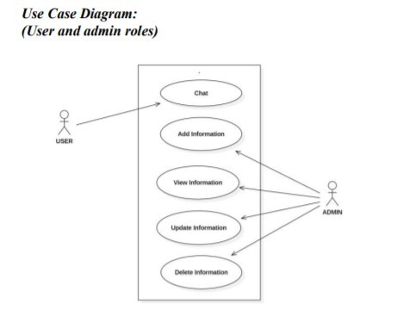

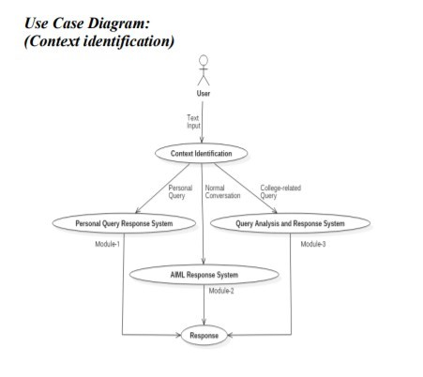

#### Class Diagram

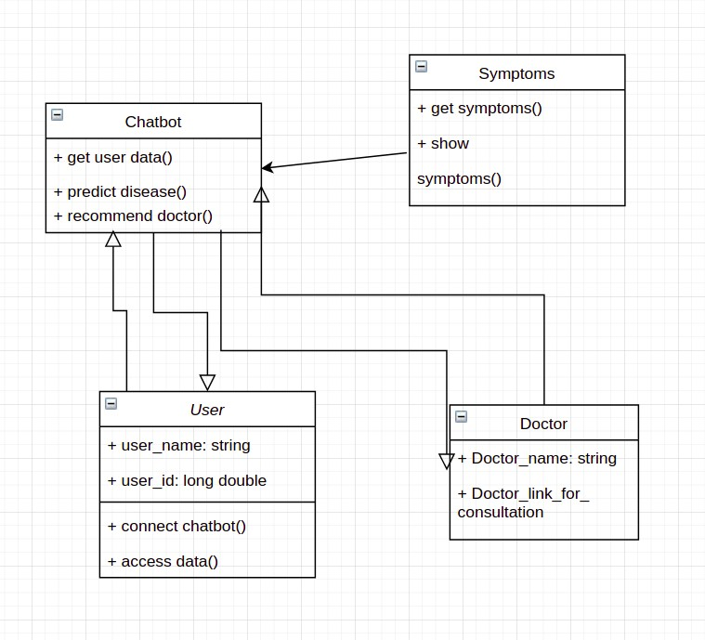

#### Activity Diagram

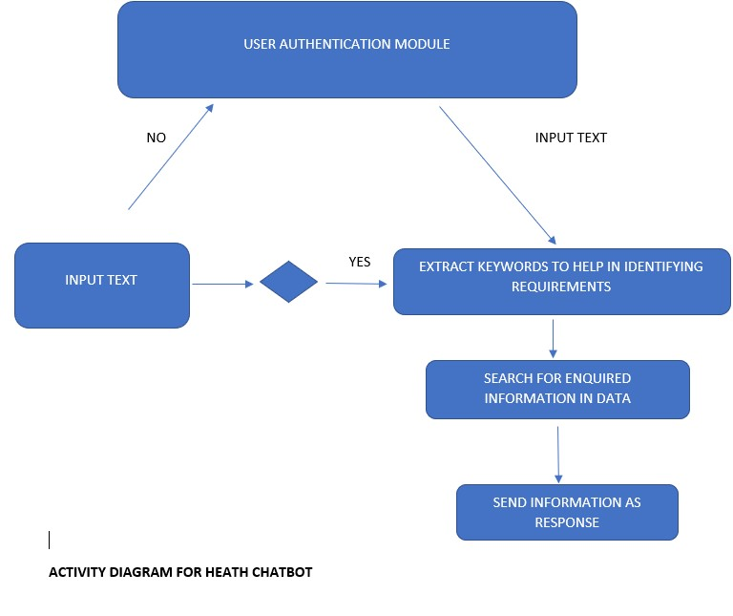

#### Sequence Diagram

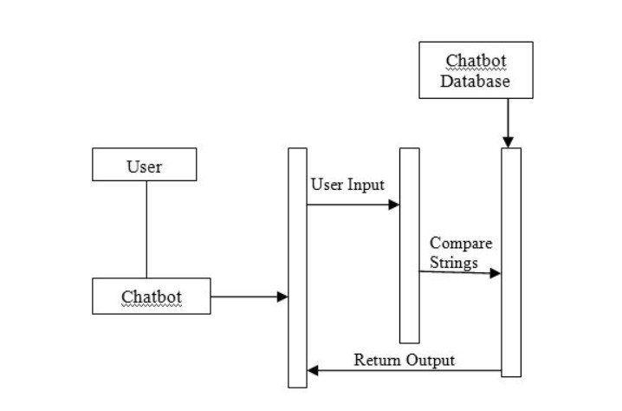

#### Data Flow diagram

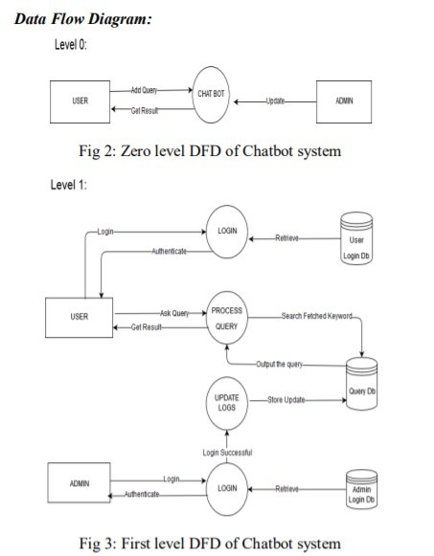

#### 2.8. Assumption and Dependencies

Let us assume that this application is used in the following application:

An user needs to be aware about the symptoms properly to get the highest accuracy in the results predicted by the chatbot.

User needs to know the basic functionality for how to use the chatbot such as log in, register,etc.

#### 3.0. System requirements

##### 3.1. User Interface

* tkinter
* os

##### 3.2. Software Interface

|  |  |
| --- | --- |
| **Software used** | **Description** |
| Operating system | We have chosen windows operating system for its best support and user-friendliness. |
| tkinter | Tkinter is a Python binding to the Tk GUI toolkit. It is the standard Python interface to the Tk GUI toolkit and is Python's standard GUI. Tkinter is included with standard GNU/Linux, Microsoft Windows and macOS installs of Python. |

**Table 1:Software Interfaces**

##### 3.3. Database Interface

|  |  |
| --- | --- |
| Database | To save the user details (login credentials) will be stored in the file so that it can be accessed while logging in after registering once. |

**Table 2: Database Interface**

##### 3.4. Protocols

·browser

·the definition of message formatting.

#### 4.0. Non Functional requirements

##### 4.1. Performance requirements

Firebase : Firebase provides tools for tracking analytics, reporting and fixing app crashes, creating marketing and product experiment

Chatbot : Chatbots offer a wide range of applications and are not limited to one industry or use case. For example, common use cases are: Customer Service: Answering FAQs, support in case of problems.

Marketing: Lead generation, product consulting, data collection, increased interaction.

##### 4.2. Security requirements

Access of administrative staff to the bot management system needs to be tightly controlled through built in role based security and multi-user management.

**4.3. Software Quality Attributes** Performance :

* Avoid inappropriate utterances and be able to perform damage control.
* Chatbot should be able to answer all the common questions asked by the user.

Functionality :

* Interprets commands accurately
* Contains breath of knowledge, is flexible in interpreting it

Accessibility :

* Can detect meaning or intent
* Responds to social cues

Affect :

* Give conversational cues

### Appendix A: Glossary

This document uses the following conventions.

|  |  |
| --- | --- |
| DB | Database |
| User | User can login, register and ask queries related to the health issues they are facing. |